B1E Havo/VWO Onderwerp: negatieve getallen

1  -12 … -20 | 2  –17 +- 12 = | 3  -8 - (8 – – 10) = | 4  7 x (–6 – – 6) = | 5  -59 - -78 – 9 = | 6  $-\frac{6}{10}$ … $-\frac{1}{10}$ =
7  –49 + 39 - -7 | 8  0– 9 = | 9  12 + – 26 = | 10  -6$\frac{1}{2}$ … – 6$\frac{3}{4}$ | 11  ( –17 + – 8 ) + 5 = | 12  $\frac{1}{2} x$(–9 – +13) =
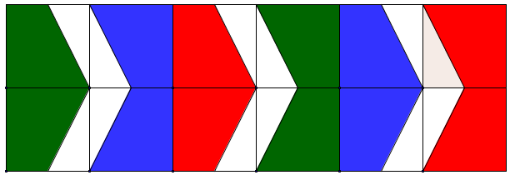

1  0 | 2  – 9 | 3  -24 | 4  < | 5  = | 6  – 20
7  -3 | 8  – 29 | 9  10 | 10  > | 11  – 11 | 12  – 14

